Exercise 1:

(a) Entity Types and Attributes
- Newspaper: Name, FirstIssueDate
- Publisher: Name, Address, Manager
- Issue: Date
- Person: Number, Name, Address
- BankAccount: IBAN, AccountHolderName
- Delivery: ShipmentNumber
(b) Primary Keys
The appropriate primary keys (PK) for the entity types are:
- Newspaper: {Name, FirstIssueDate} (Composite Primary key)
- Publisher: {Unique Name}
- Issue: {Newspaper.Name, Newspaper.FirstIssueDate, Issue.Date})
- Person: {Unique Number}
- BankAccount: {IBAN}
- Delivery: {ShipmentNumber}
(c) Relationship Types
The following relationship types are identified, complete with their attributes, connected entity types, and cardinalities (using (min, max) notation for precision where applicable, or standard N:M).
- Publishes
Connected Entity Types & Cardinalities:
  - Publisher (0, N)
  - Newspaper (1, 1)
- Has (Identifying Relationship for weak entity 'Issue')
Connected Entity Types & Cardinalities*:
- Newspaper (1, N)
- Issue (1, 1)
- Subscribes (Ternary Relationship)
Attributes: Vacation
Connected Entity Types & Cardinalities:
  - Person (0, N)
  - Newspaper (0, N)
  - BankAccount (0, N)
- Sent_To
Connected Entity Types & Cardinalities*:
- Delivery (1, 1)
- Person (0, N)
- Contains
Connected Entity Types & Cardinalities*:
  - Delivery (1, 1)
  - Issue (0, N)
Exercise 2
The situation describes a ternary relationship between `Company`, `Part`, and `Product`. Since no specific constraints are given, we must model the most general case where the relationship is many-to-many-to-many (N:M:P). This means a company can supply many parts for many products, a part can be supplied by many companies for many products, and a product can have its parts supplied by many companies.
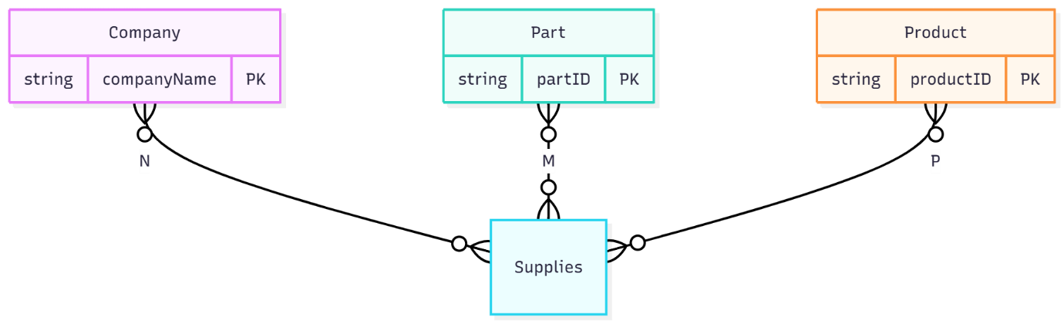

b) No. In the general case described above (N:M:P), this situation cannot be accurately represented with only two binary relations.

we would lose the essential link of information. We would know that a company supplies a certain part, and that the part is used in a certain product, but we would not know if that specific company supplies that part *for that specific product*. This would allow for incorrect connections to be inferred that do not exist in the original ternary relationship.
(c)
Yes when cardinality of 1 exists on one of the participating entity sets.

if a company and a part uniquely determine the product it is for, the cardinality on the Product side would be '1'.
This would mean `Company x Part -> Product`.
(d) Yes, it is always possible to represent a ternary (or any n-ary) relation with multiple binary relations.
The method is to introduce a new, central entity type that represents the relationship itself. This new entity is often called an "associative entity" or "relationship entity".

1. Create a new entity type to represent the relationship (e.g., `Supplies_Link`).
2. Connect each of the original three entities (`Company`, `Part`, `Product`) to this new central entity using three separate binary relationships.

The primary key of this new Supplies_Link entity would be a composite key formed from the primary keys of Company, Part, and Product. This structure perfectly preserves the original N:M:P relationship by ensuring that every instance in Supplies_Link links exactly one company, one part, and one product together

